DXDCH-10A

INTRODUCTION OF AUTOMATIC

TEA-BAG PACKAGING MACHINE

Operations of DXDCH-10A and debugging:
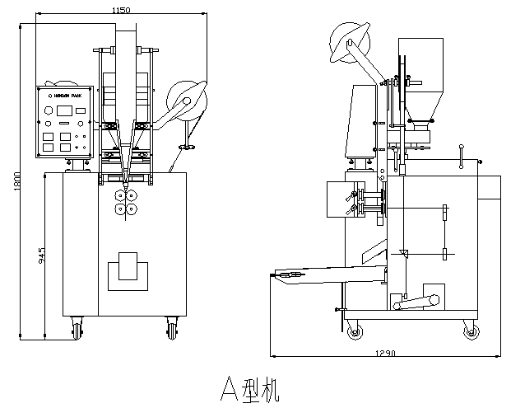
I. Structure:
The machine is including of temperature controlling, bag-making, hanging up line, feeding tag, falling materials, cutting thread and cut tag, etc..
II. Main steps:
1,Turn on power switch, set the temperature of longitudinal sealing roller between 130ºC-140ºC, transverse sealing roller between 130ºC-150ºC,and tag between 110ºC-120ºC. (usually, for different materials and characters, it can be adjusted properly.)
2. check every part of machine is in normal condition, and make sure there is no looseness in every binding bolt. Please act at your discretion.
3. open the switch, make the machine run. Observe if the machine runs correctly, and listen if there is abnormal sound.
III. Coordination of longitudinal sealing roller and transverse sealing roller.
Longitudinal sealing roller is derived by horizontal axis(up 04, down 04). There is a adjustable offender sprocket wheel in the left of horizontal axis. For the needs of bag making, the Longitudinal sealing roller doesn’t speed uniform. However, for a complete set of longitudinal and cross sealing rollers, offender sprocket wheel should move 45º to the horizontal plane.
Schematic View:

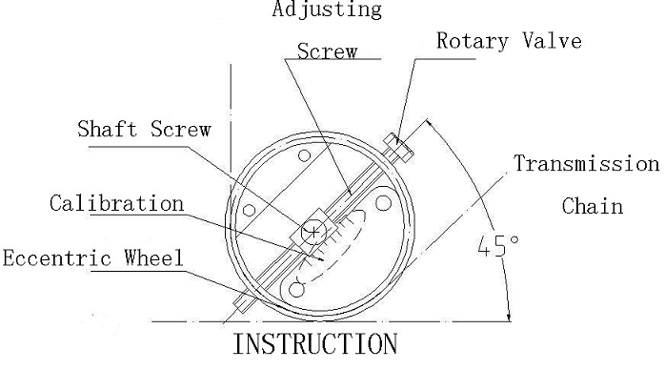

Eccentric wheel makes the longitudinal sealing roller turn regularly. When longitudinal sealing and cutting, the sealing roller operation means the connection of them from quickly to lowly.
IV. Adjust operations and debugging.
(I)bag-making:
1, put tea-filter paper and tag board on relevent axises, and centerline of filter paper correspond to the point of heating sealing of transverse sealing roller. Through the paper guide roller, filter paper enter to transverse sealing roller. Tag board align at tag sealing roller, through the tag guide barrel(turn on the falling clutch, delivering clutch, outer bag clutch), turn off clutch, start up electric motor and begins making bags. Length of bags: 50mm-60mm.. change the length of bag wheel gear, then length of bag changed.
2, 50mm length of bag, offender bolting cut turns to bottom, and make the angle biggest.

The length of inner bag is between 50mm and 60mm, when it is above 50mm, should smaller the angle of offender, and make sure don’t support or pull bags.

3, align former on the point of cross heating. If there are folds on bags, then move the former right and left(shift the side of more folds to opposite side). If the bags are not the square or rectangle, it means the paper direction isn’t 90 to the Longitudinal sealing roller, should adjust properly.
(II) hanging up the line:
1, put the spool into thread protection box, then through one end of thread to coil former top down, then to hole of thread, at last to the hole of delievering thread(stainless steel).
2, delivering board works to and fro through offender board, Size of board and link rod can adjust the length and location of thread. When adjusting, it’s better the thread not touch the former, not touch the cross sealing roller and at the same time it can through the hole, pressing part of thread is better to 15mm to 20mm to delivering mouth.
2,when delivering thread slide board works, link rod drives down slide board, and down slide board with up slide board moves to and fro. Attention: when slide board moves in the hole, make sure the up slide board freeze, or thread doesn’t tight and it would drop put.
4,when it becomes drop out, please check drawing lines is clear. Adjust screw in the slide board to increase friction force.
(III) falling materials:
1, the parts of falling is including of material cup, adjustable cup, up and down pin, switch circuit controller, etc. during adjustment, first fixup and adjust up and down pin. When counting cup right to the former, pin open switch circuit controller right. Down pin should switch down the switch circuit controller, avoid leaving out..( turn right the up and down pin and switch circuit controller, make it easily.)
2, adjust the time of falling materals, when Longitudinal sealing completely, falling begins. It ‘s early or late, materals would be cliping. When on operation, supporting up the falling time gear, turn materals cup gear clockwisely.

(IV)cut the thread
1.The cutter should be sharp.The pressure spring of cutter should be suitable.It will not benefit to cut the thread if the pressure is more strong or week.In addition,please remember to adjust the degree of pressure spring.
2.Adjusting the time of cut the thread:The bottom slide move from back to front,upper slide didn’t move,when the cutter get ready to cut,the thread is in the condition of slack and vertical.And this time is the best time to cut.It is convinent to hold the tag when the tag fall down stablely.
3.The time of cutting the thread can be adjust by the cam which on the bottom of horiziontal axis.
(V)Feed the tag
1.Feeding the tag can be done by swing of fan-shaped gear.The length of tag can be adjust by the adjust suppository which on the fan-shaped gear bracket.The length of tag should be longer than 20mm.
2.The movement of feeding the tag is two time.For the thread is sealed in the tag,we should adjust a best time.When the thread fall in the tag sealing roller,it is better that the first time of feeding tag has finished,in other word,it is better that the thread has been sealed when the first time of feeding tag and then the second time of feeding tag has finished.
3.The pressure of tag sealing roller isn’t too strong ,and the temperature should be medium.If using the strong pressure and the high temperature,the tag may be bending.and it is easy to be jam.
4.The time of feeding tag can be adjust by feeding tag cam which on the horizontal axis.
(VI)Cut the tag
1.It begin to cut the tag when the second feeding tag finished.Maybe the tag will be clog if the machine cut the tag more early or more lately.
2.Adjust the time of cut the tag:It can be done by the cam of cut tag which below the vertical axis.(09)

V．maintenance
1.Examine all the spare parts of the machine regularly.When you find some problems,solve them in time.And make sure luminate the gear which need lumination regularly.
2.make sure clearance of promixity switch,speed switch and speed gear in order to prohibit the sensitivity decrease.

