3~100kw Automatically Controlled
Mini Hydraulic Generating Units
Product Manual for Installation and Operation

Special notice:
Please read this Manual after choosing this product;
New users are suggested to learn from experienced ones to obtain the practical experience guidance on type selection, construction, installation and operation.
- Properties of Unit Performance
- This type of units is applicable to generate by using the hydraulic resources of rivulets in out-of-the-way mountainous region. The electricity is used for lighting, cooking, electric appliances. The units are horizontal type and can directly drive the rice mill or breaking machines if equipped with belts. It is a good way of making money!
- This type of structure has properties of simple and reliable structure, fewer components, simple and convenient operation and operation.
- The generation operation is of automatic control, and voltage and frequency is of automatic stabilization, and keeping watch all day long is unnecessary.
- Considering of properties of lack in technique, difficult to get fittings and difficult service for the out-of-the-way region, the design and manufacturing for the unit can guarantee the long-term operation lifespan (over 25 years). Rubber components can be easily replaced. The cavitation and noise are very low and the performance is excellent.
These types of units are widely exported to other countries and gain good reputation from the customers. Now the products are of serialization. We can make the preliminary design according to the design heads and flows provided by the customers.
- Type Selection
We can design and manufacture the units if the Customer provides the gross head, flow in dry season, normal flow, installed capacity, elevations, etc.
Gross head: the vertical height difference between the upstream and downstream water levels of the power plant. For the measurement, please refer to the attached drawing;
Flow: water amount per second. You may fill a container with water flow in one minute, get the cubic value and divide with 60; or the water passage area times the flow velocity. Place a floating article on the canal. And divide the floating distance in one minute with 60. Get the average values of several times. And please consider the variation of water flow of different seasons.
Output estimation: generating electricity = 9.8x rated head (m) x flow( m³ /s) x turbine efficiency x generator efficiency in kw
Rated head, usually equal to 90% of the gross head, the turbine efficiency is 0.6～0.75, and generator efficiency is 0.84～0.89
- Structural Property
- Turbine: for lower heads, horizontal shaft extension tubular units will be used. We carry out the serialization production to guarantee each turbine can be operated under optimal working condition. It is of low cavitation, high efficient, small vibration, stable operation, and thus the cavitation damage of the components is greatly decreased and the maintenance reduced too. And the lifespan of the unit is increased to a great extent. For the turbine, stay vane introduces the water into the runner, and turbine guide bearing is made of wearing material for special purpose. The structure is very simple and reliable. Resilient coupler is used to connect with the generator directly, or to drive agricultural machinery with belts. For higher heads, horizontal turgo impulse (Or pelton) turbines will be used. The structure is: the generator shaft extends into the turbine and connects with it directly and the units are integral. Needles are set at inlet of turbine to adjust the water flow for the turbine. At the other end, the generator can be equipped with multi-purpose belt to directly drive the agricultural machinery.
- Water diversion mode：Steel pipes are usually used for diversion. Manual gear worm driven butterfly valve is used to control the turbine.
- Generator：3 (1) –phased AC synchronized generator is used.
4） Overall control cabinet for the unit: The cabinet has functions such as generator parameter acquisition and display, voltage control, frequency control, unit protection. The operation is very simple. Generator output voltage frequency is automatically controlled by the electronic adjuster. Residual electricity will be balanced by the FALSE load to keep the voltage and frequency in some range. And there is no need of keeping water for all day long.
- Technical Parameters of the Unit
Rated capacity: 3, 5, 7.5, 10, 12, 15, 20, 25, 30, 40, 50, 75 and 100kw
Rated voltage: single phase 220Ｖ ( usually less than 15kw), 3-phase 380V ( usually more than 15kw)
Frequency: 50/60Hz Rated speed: 1500/1800rpm Power factor: 1(0.8)
Efficiency of generating unit: 55% (3kw) ~75 %( 100kw)
FALSE load power: same as rated capacity
Excitation device mode: harmonic excitation
Voltage variation range ±5%
Frequency variation range 49～51Hz/59～61Hz
- Notice for Mounting and Operation
- Mounting position should be where the flood can not reach, or anti-flood wall should be built.
- The volume of the fore bay is usually not more than the necessary flow of turbine in 2 minutes. The inlet pipe should be at least 0.5 meter lower than the fore bay level, and 0.2 meter higher than the bottom surface of the bay. Steel wire trash rack should be set before the inlet pipe to avoid blockage to nozzles or damage of impellers due to sandstones or sundries. The inlet pipe diameter should be 1 time the water-diversion pipe area. The fore bay and the inlet pipes should be reliably fastened by concreting.
- The water-diversion pipe of steel material will be a better choice. No leakage and reliable fastening should be guaranteed.
- The unit should be close to the housing for convenient management and to reduce the line loss. The line within 1000m will be better.
- For mounting the unit, concrete the drain ditch, and pay attention not to submerge the unit. The unit should be mounted in a level. Fasten the foundation bolts. For angular impulse turbines, the ditch depth should be 1.5 times the outer diameter of the runner.
- For the FALSE load of the unit, electric furnace or water resistor will be used. After aging, the furnace fuse should be replaced in time. The water resistor should be kept under the water. Due to different water quality in different regions, it is necessary to adjust the area and space between tinplates of the water resistors. Increasing the area of the tinplate or decreasing the space between tinplates will cause an increase in power, and decrease whereas.
- Frequently check the contact of the brushes and collect ring. Clean the surface dirt on the collect ring with cloth. Check if the spring is loose. Adjust it if necessary. The brushes should be replaced in pairs when they are with one third left to keep the balance of pressure.
- According to the starting procedure of turbine, first make the set rotating at half load for 2 hours. Check if the bearing temperature and the whole set is normal. If everything is normal, increase the speed to the rated value and operate for 2 hours at the speed. After normal operation at no load, gradually increase the speed to full load by 25%, 75%, 100%, and 72-hour continuous operating test with load should be done. Pay attention to the conditions of each part. If something abnormal, stop the set in time and get rid of it.
- When there is no enough water in dry seasons, the tubular units should be equipped with a separate runner with less passing water capacity for the seasons.
- When directly driving the agricultural machinery with belts, 3kw unit is equal to 4.5kw motor, and 5kw unit equal to 7.5kw motor and 7.5kw unit to 11kw motor.
- The User should let electricians mount and test the generators, electric wires and appliances. After supervised by the electricians, and acquainted with generating and using knowledge, the User can only carry out operation by himself.
- Maintenance
- Avoid the generator exposed to the atmosphere and put up a shed or cover if necessary. But the generator should be kept well ventilated. Frequently remove the sandstones or sundries in the bay and nozzles.
- Usually grease the bearing once every 3 months. After wearing of rubber bearing in turbine, put 0.2～0.3mm thick pads under the rubber bearing to guarantee the clearance between the runner below and turbine body.
3）If abnormal sound happens in the generator, stop the unit timely and find out the fault for repairs (possibly due to damage of bearing or blockage in flow passage in turbine due to sandstones and sundries).
- Notice
The generating equipment is with electricity! The operating personnel should be familiar with electric knowledge for safe operation;
Frequently check if the FALSE load is damaged. Stop the unit and replace it if damaged!
Water resistors should be filled with water.
Pay attention to the safety operation for the generating unit! Keep the children or non-operating personnel out of the equipment!
- Others
  - Contact telephone: 086-10-88691269
Address: 401-4-8, LUGU CUN, SHIJINGSHAN, BEIJING, 100041, CHINA
Http：// www.mycotrade.com/enm.htm E-mail:sales@mycotrade.com

China machinery and equipment im&ex group/Beijing yiyuan economic trade ltd

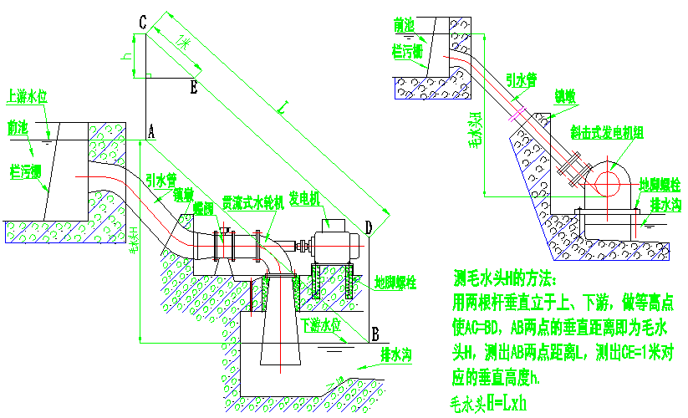
上游水位：upstream level; 前池：fore bay; 拦污栅：trash rack; 引水管：diversion pipe; 锁墩：locking pier;蝶阀：butterfly valve; 贯流式水轮机：tubular turbine; 发电机：generator; 地脚螺栓：foudnation bolt; 下游水位：downstream level; 排水沟：drain ditch; 毛水头：gross head;
Measuring method for gross head H:
Place two poles vertically at upstream and downstream, make AC equal to BD. The vertical distance between Point A and B refers to the gross head, and measure the distance L between A and B and the vertical height responding to CE ( 1m). Gross head H=LXh

